

#4

Latest Round-ups:
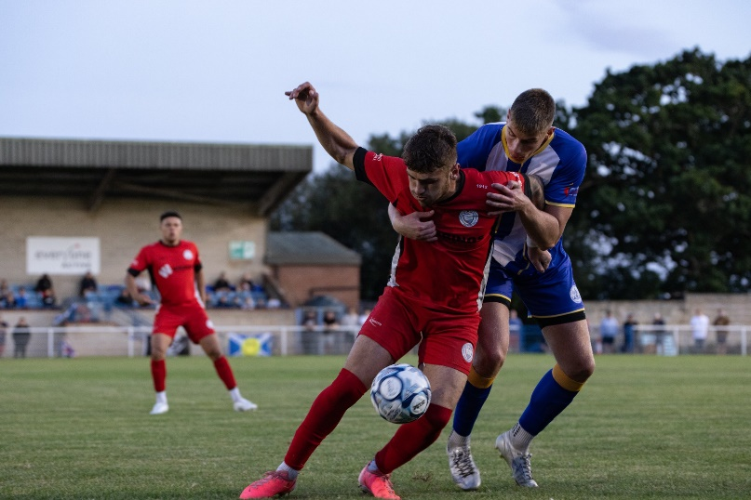
Midweek Action: In another busy midweek round of fixtures, Barnstaple’s strong run of form continued thanks to a last-gasp 2-1 victory over Wellington. Having fallen behind at the end of the first half to a Jake Quick goal, Town got back on level terms through Josh Parry, before substitute Ricky Marinaro popped up to claim the late winner four minutes from time. Elsewhere in the Premier Division on Tuesday evening, Buckland’s Jared Lewington headed home in the 79th minute to give his side a 1-0 win at Saltash, while Street beat Welton 3-0 thanks to goals from Callum Laird, Stu Bowker and Connor Linham. There was also a return to winning way for Paulton, with first half goals from Dan Cottle and Kye Simpson leading them to a 2-1 victory at Shepton Mallet, but no goals in the all-Devon clash between Brixham and Ilfracombe at Wall Park. Brislington were another side to leave it late, with sub Danny Barwood scoring in the closing stages of their 2-1 win over Oldland Abbotonians, while Bridgwater suffered their first loss after going down to a 3-1 defeat at Nailsea & Tickenham. After going 2-0 up courtesy of Shea Mannings and an own-goal, the Swags lost their clean sheet late on, before eventually wrapping up the victory thanks to a belter of a goal in the final moments from Miles Hardidge. The standout result on Wednesday night saw St Austell put five past Torpoint to secure their first points of the campaign. George Marris was the star of the show for the hosts, bagging a hat-trick, with Adam Carter and former Torpoint forward Curtis Damerell also finding the back of the net during the one-sided Cornish contest. The other two games that evening saw the points shared, with Ivybridge and St Blazey drawing one apiece, and local rivals Clevedon and Portishead both scoring in the closing stages of their 1-1 draw (pictured in action, right). The hosts had gone ahead 15 minutes from time courtesy of Harrison Kyte, but Portishead hit back shortly after, and maintained their unbeaten start thanks to a deflected free-kick from Mitch Osmond.

Many of the early season front-runners enjoyed fruitful midweeks in the First Division, including Calne Town who stormed to a 5-0 win over Gillingham. Having been held goalless for the opening 45 minutes, a five-goal blitz after the interval saw the Lilywhites grab their fourth win of the campaign, with Josh Pike-Bright, Stuart Windsor, Ackeem Stewart, Nat Bell and Sam France all netting. Hallen left it late before confirming their win at Bitton, with substitute Toby Walwin coming off the bench in the final quarter before scoring the only goal of the game with nine minutes remaining. There was also a late winner for Avonmouth who overturned a half-time deficit to beat Hengrove 2-1. Having trailed to Oscar Sullivan’s opener, the levelled affairs through sub Dillan Kerr, before then snatching all three points in the 88th minute thanks to a goal from in-form frontman Charlie Aldom. Another come-from-behind victory saw Dan Demkiv and late sub Sam Jordan score for Bradford Town in their 2-1 win at Longwell Green, while Cribbs Reserves made it back-to-back wins after holding on to beat Keynsham by the same scoreline. Luke Hopper scored another brace in Devizes’ 3-0 defeat of Sturminster Newton, with James Batchelor also scoring twice in helping to lead Bristol Telephones to a comfortable 4-1 defeat of AEK Boco. The other fixture that night ended in a dramatic 2-2 draw, with Mendip Broadwalk striking at the death to deny Odd Down. The Bath outfit had overturned a half-time deficit to lead 2-1 courtesy of goals from Abdoulaye Ndiaye and Nathan Hall, but were unable to hang on with Rhys Hickery striking in stoppage time to secure a point for Mendip. There was another impressive turnaround on Wednesday evening, with Shirehampton beating Cheddar 3-1 despite finding themselves a Lewis Chappell goal down at the break. Chappell’s goal right at the end of the first half was eventually cancelled out on the hour by Tom Trimble, with fellow home forwards Tristan Baker and Ryan Radford then completing the comeback during the final 20 minutes. Cadbury Heath picked up an impressive 2-1 win at home to Radstock thanks to goals from Tyler Lane and Miles Scott, while Warminster’s Reece Collyer fired home a rocket into the top corner to secure a point in their 1-1 draw with Wells City.
FA Cup: Barnstaple Town will continue their run in this year’s FA Cup after storming to a 4-1 win over last season’s Western League runner-up Falmouth. The visitors were no match for Barnstaple who were irresistible during the opening minutes, going two goals ahead thanks to Josh Parry and Ryan Keates. Another volleyed effort from Keates made it 3-0 after only 20 minutes, with Falmouth stemming the tide slightly following a goal from Oscar Massey. Any chances of a fightback were ended early in the second half, when Gabby Rogers scored his second goal of the campaign to complete the one-sided victory. A couple more Premier Division sides will hope to join Barnstaple in the next round, and remain in the hat after setting up midweek replays. Nailsea & Tickenham have goalkeeper Jacob Glover to thank for preserving their 1-1 draw at Reading City, after he saved an 89th minute penalty. The Swags had gone ahead midway through the first half courtesy of Seb Scott, before being pegged back in the early stages of the second half by Reading’s Ellis Cowd. It remained one apiece for much of the second period, until the hosts were awarded a late spot kick, but Glover managed to keep out the shot on goal and give his side another crack at their Berkshire opponents. Sunday’s lone tie saw success for Paulton Rovers who hung on to secure a 2-1 win away at Hamworthy Recreation. A perfect start for the visitors saw Kye Simpson firing home in the sixth minute following strong work down the right from Dan McBeam. A second Paulton goal then finally came 20 minutes from time, with Corey Rawlings reacting quickest to a loose ball in the home area. Hamworthy set up a tense finale after scoring from the spot, but Rovers had enough in hand to complete the win despite plenty of late shots raining down on their goal.
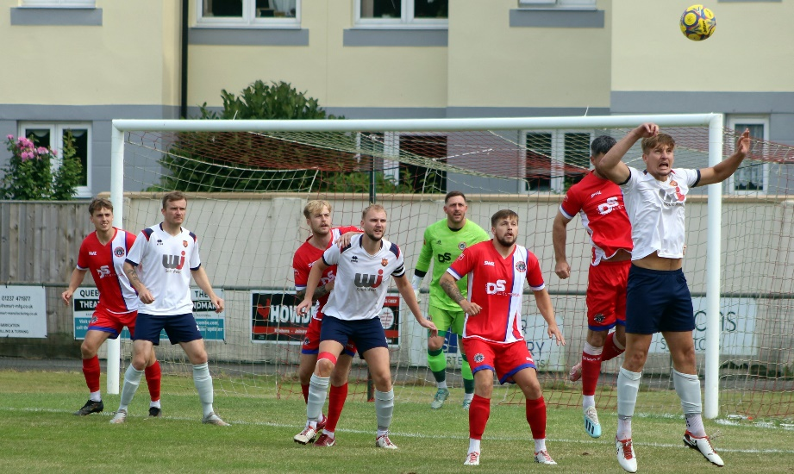
Wellington are another who will host a replay having been denied at the death by Bideford on Saturday afternoon (pictured, right). The Tangerines looked to have done enough following a header late in the first half from skipper Kieran Bailey, but it wasn’t to be, and the home side managed to find an equaliser in the seventh minute of stoppage time. Brixham will also meet up with Exmouth again, after their tie had to be abandoned following a bad injury suffered by a member of the home side. Things didn’t go too well for Clevedon who conceded three goals in the opening quarter of their 4-1 defeat at Amersham, while Ivybridge were knocked out by Tavistock who edged to a 1-0 win following Victor Odiaka’s 83rd minute effort. Shepton Mallet’s run in the competition was also ended following a 2-1 loss at Baffins Milton Rovers. Having fallen behind early on, Mallet drew level early in the second half thanks to a curled finish from Cam Allen. The visitors didn’t manage to stay level for long however, and it was the Portsmouth side who progressed following a smart finish from Danny Burroughs on the hour mark.

Premier Division: In a reduced set of fixtures, only to the cup games, away sides enjoyed the best of the day in the Premier Division, with Buckland among Saturday’s winners. The game was pretty much done and dusted within 20 minutes, with Ryan Bush and Jared Lewington taking it to the Torpoint defence. Lewington struck twice, including a third minute penalty, which sandwiched Bush’s effort as Buckland scored all three of their goals in no time whatsoever at The Mill. Brislington found it tougher to claim their three points, having to stave off a fightback from Saltash to eventually prevail by three goals to one. After Oaklan Buck had put them ahead, Bris were pegged back on the stroke of half-time when Tom Payne’s free kick was headed home by Kieran O’Melia. The away side regrouped at the interval, coming out firing in the second half, and scoring twice within ten minutes of the restart courtesy of Asa White and Owen Humphries. The other away side to claim victory was Portishead, with the 3-0 win at Ilfracombe helping to extend their unbeaten start. A near post effort from Ethan Feltham gave the away side the desired start, putting them a goal to the good after only nine minutes. Ben Bament then doubled the advantage shortly after the break, with Feltham teeing up youngster Jake Packham who added the finishing touches during the final few minutes. The only home winner was Oldland Abbotonians, who overturned an early deficit to beat Welton 3-1. An early Mason Alden had given the winless Welton a dream start, and they managed to hold out for much of the game, maintaining that advantage until the 70th minute when Oldland came to life, with Brandon Oputeri’s leveller setting up a thrilling finale. Unfortunately for Rovers, it was the hosts who pushed on to secure victory, with a stoppage time header from Kristian Miller followed shortly after by a Tom Blake penalty to hand the Abbots successive home wins.
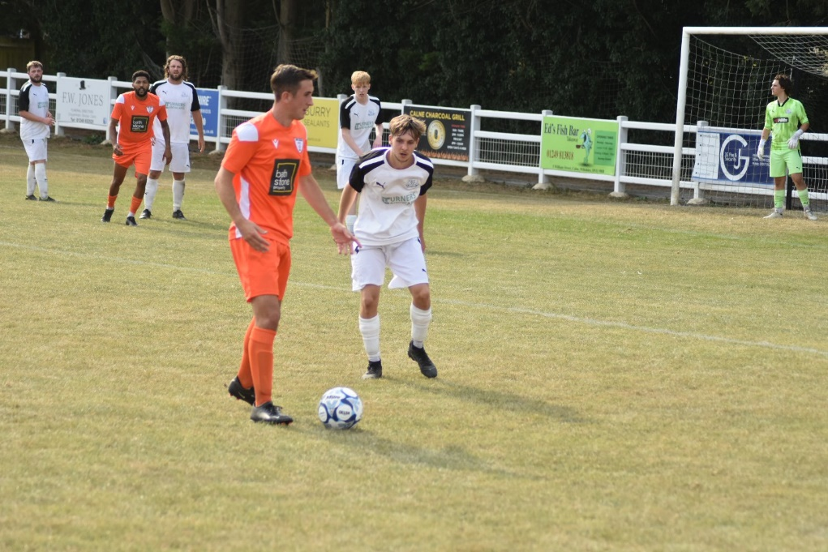
First Division: Another standout performance from Avonmouth has prolonged their time at the top of the table, with five different scorers leading them to a 5-1 win at Gillingham. Having seen Kofi Martin’s 17th minute opener cancelled out by an own goal, Avonmouth restored their advantage at the end of the first half through Matt Groves. A third goal on the hour mark from Mitch Wise put the visitors two clear, with Alfie Taylor and Evan Howse adding to the one-sided nature of the scoreline late on. Calne Town’s strong early season progress also continued, with a pair of first half efforts from Nat Bell and Sam Jones leading them to a 2-0 win over Odd Down (pictured, right). The only 100% winning record is still intact after Bradford ran out 2-0 victors away at Shirehampton. Taking on a previously fellow-unbeaten side, the Bobcats had Jack Witcombe to thank for their latest three points, after his two goals either side of the interval proved to be the difference between the teams. Fourth-placed Devizes came back to claim a 1-1 draw at home to Cribbs Reserves, while Hallen powered to a 6-1 win at Radstock. In a tight start to the contest, Tom Ellis-Ricketts struck for Radstock to draw them level in the 34th minute after Ethan Johnson had tapped the visitors ahead. Hallen then produced an incredible spell in the lead-up to half-time, with Lewis Saunders scoring twice in the space of five minutes to make it 3-1. That wasn’t the end of the scoring however, and in first half stoppage time there was enough time for Jack Sheppard-Couzens to slot home to put Hallen three goals in front. Jordan Greenwood put the game out of reach just prior to the hour mark, with Kyle Sampson then bagging a late sixth to help extend Hallen’s unbeaten start.
The individual performance of the day belonged to Sturminster Newton’s Aaron Lane-Leney who struck a hat-trick in their 4-1 home win over Keynsham. A pair of first half strikes from Lane-Leney helped the hosts edge ahead at the interval, before he completed his treble in the 61st minute to help push the Abbots back into the winner’s circle. Elsewhere, two goals from Sacha Tong were a major factor in Bitton’s 4-0 win over Warminster, while a first half effort from Cam Nicholson helped Wells City eek out a 1-0 victory at home to AEK Boco. There was also a 1-0 win for Cadbury Heath away at Cheddar, thanks to Jacob Littlewood, with Longwell Green defeating Hengrove 3-0 courtesy of goals from Billy Hensler, Jordan Metters and Zac Feltham. Meanwhile, early season local bragging rights went to Mendip Broadwalk after they came from behind to beat Bristol Telephones 2-1. An early opener from Matt Martin had put the Phones in front, but they saw their lead disintegrate around the hour mark, with Rhys Hickery and Elliot Moore scoring a pair of quickfire goals in Mendip’s impressive comeback.

Midweek Results
Tuesday 13th August 2024
Premier Division
Barnstaple Town 2-1 Wellington
Brislington 2-1 Oldland Abbotonians
Brixham 0-0 Ilfracombe Town
Nailsea & Tickenham 3-1 Bridgwater United
Saltash United 0-1 Buckland Athletic
Shepton Mallet 1-2 Paulton Rovers
Street 3-0 Welton Rovers
First Division
Avonmouth 2-1 Hengrove Athletic
Bitton 0-1 Hallen
Bristol Telephones 4-1 AEK Boco
Calne Town 5-0 Gillingham Town
Devizes Town 3-0 Sturminster Newton United
Keynsham Town 1-2 Cribbs Reserves
Longwell Green Sports 1-2 Bradford Town
Mendip Broadwalk 2-2 Odd Down

Wednesday 14th August 2024
Premier Division
AFC St Austell 5-1 Torpoint Athletic
Clevedon Town 1-1 Portishead Town
Ivybridge Town 1-1 St Blazey
First Division
Cadbury Heath 2-1 Radstock Town
Shirehampton 3-1 Cheddar
Warminster Town 1-1 Wells City


On the latest episode of the podcast, Wellington boss Richard Cherry chats about the work his club have done on and off the field which has enabled their strong start to the campaign. Ian then catches up with Bradford Town manager, Chris Carr, who talks about how the positive pre-season has enabled their winning start, while also commending the work of club volunteers who have helped transform Trowbridge Road.
https://www.westernleague.co.uk/news/podcast-episode-4

Weekend Results
Saturday 17th August 2024
FA Cup Preliminary Round
Amersham 4-1 Clevedon Town
Baffins Milton Rovers 2-1 Shepton Mallet
Barnstaple Town 4-1 Falmouth Town
Bideford 1-1 Wellington
Exmouth Town A-A Brixham AFC
Ivybridge Town 0-1 Tavistock
Reading City 1-1 Nailsea & Tickenham
Premier Division
Ilfracombe Town 0-3 Portishead Town
Oldland Abbotonians 3-1 Welton Rovers
Saltash United 1-3 Brislington
Torpoint Athletic 0-3 Buckland Athletic

First Division
Bitton 4-0 Warminster Town
Calne Town 2-0 Odd Down
Cheddar 0-1 Cadbury Heath
Devizes Town 1-1 Cribbs Reserves
Gillingham Town 1-5 Avonmouth
Hengrove Athletic 0-3 Longwell Green Sports
Mendip Broadwalk 2-1 Bristol Telephones
Radstock Town 1-6 Hallen
Shirehampton 0-2 Bradford Town
Sturminster Newton United 4-1 Keynsham Town
Wells City 1-0 AEK Boco

Sunday 18th August 2024
FA Cup Preliminary Round
Hamworthy Recreation 1-2 Paulton Rovers



Upcoming Fixtures
Tuesday 20th August 2024
FA Cup Preliminary Round
Nailsea & Tickenham vs Reading City 19:30KO

Wednesday 21st August 2024
FA Cup Preliminary Round
Bideford vs Wellington 19:45KO
Exmouth Town vs Brixham 19:45KO

Friday 23rd August 2024
FA Vase First Round Qualifying
Newton Abbot Spurs vs Ivybridge Town 19:30KO
Sandhurst vs Nailsea & Tickenham 20:00KO
First Division
Avonmouth vs Cribbs Reserves 19:30KO

Saturday 24th August 2024 (3pm Kick-off unless noted otherwise)
FA Vase First Round Qualifying
Berks County vs Calne Town
Callington vs Shepton Mallet
Crediton United vs Buckland Athletic
Folland Sports vs Sturminster Newton United
Hallen vs Portishead Town
Hamworthy United vs Warminster Town
Hengrove Athletic vs Shirehampton
Newent vs Cadbury Heath
Odd Down vs Brislington
Oldland Abbotonians vs Cirencester
St Blazey vs Saltash United
Street vs Elburton Villa
Tytherington Rocks vs Keynsham Town
Wadebridge Town vs Cheddar
Wantage vs Bitton
Premier Division
AFC St Austell vs Clevedon Town
Barnstaple Town vs Torpoint Athletic
Bridgwater United vs Brixham
Ilfracombe Town vs Welton Rovers
Paulton Rovers vs Wellington
First Division
AEK Boco vs Mendip Broadwalk
Bradford Town vs Radstock Town
Longwell Green Sports vs Devizes Town
Wells City vs Gillingham Town

