

#8

Latest Round-ups:
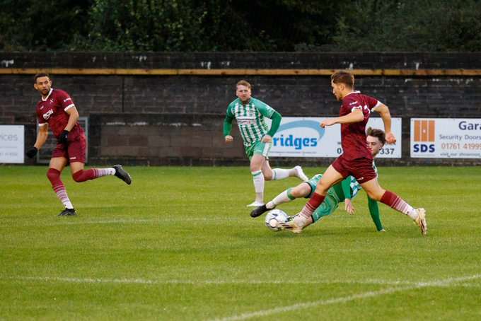
Midweek Action: A busy start to the month continued during the week with most sides in action on Tuesday and Wednesday, and it was a high-scoring round of fixtures across the league. In the Premier Division, Barnstaple secured another notable scalp by winning 3-1 at Bridgwater. Following on from their impressive victory at the weekend, Town fell behind at Fairfax Park with an unfortunate own goal handing the hosts a 12th minute lead. Gabby Rogers continued his red-hot form, levelling for Barnstaple, before a belting finish from Mitch McCann then turned the game in their favour before half-time. Another goal from Rogers at the beginning of the second half extended Barnstaple’s lead further, and it proved to be enough to secure their sixth league win of the campaign. Tuesday also saw a big rebound for Brislington, with Ali Sen scoring a first half hat-trick in their 6-0 win over Welton, while goals in either half from Jaden Maslen and Tom Mortimore led Brixham to a 2-0 defeat of St Austell. Another big home win was enjoyed by Oldland Abbotonians, with Brandon Oputeri bagging a treble in their 4-0 victory over FA Cup hopefuls Nailsea & Tickenham. It was also a good night for Saltash, with a strong second-half showing leading them to a 3-0 win at Ilfracombe. Following a goalless 45 minutes, Kieran O’Melia took advantage of a miss-kick by the home keeper to put the Ashes ahead. Tom Payne then curled a delicious free kick into the top corner for 2-0, before Deacon Thomson added the finishing touches late on. Street’s unbeaten run continued away at Paulton in one of the evening’s big games, stealing all three points in a late salvo (pictured, right, courtesy of Jenny Short). A tight contest looked to be headed towards a stalemate, but Callum Laird had other ideas, knocking the ball home in the 84th minute to edge the Cobblers to a hard-fought victory. Tuesday also saw a much-needed victory for Shepton Mallet who secured their first three points since late July thanks to a thumping 5-1 win over Wellington. Having gone ahead early on through Jacob Sloggett, Mallet’s Josh Jenkins then scored from an acute angle to put his side two goals to the good. Sam Sheldrake’s deflected effort got Wellington back into the contest after 26 minutes, and that was how it remained until the final few minutes. Shepton finally settled the nerves five minutes from time when Jenkins slid home for 3-1, with the same man then completing his hat-trick, before Cam Allen added a fifth in stoppage time.
In Wednesday’s lone fixture, Ivybridge kept another clean sheet on their way to a 2-0 win at St Blazey. The Devonians are now riding a five-game winning streak, all without conceding, and four of those coming away from home, with Jake Miller and Ollie Aplin scoring midway through the second half in their latest triumph.
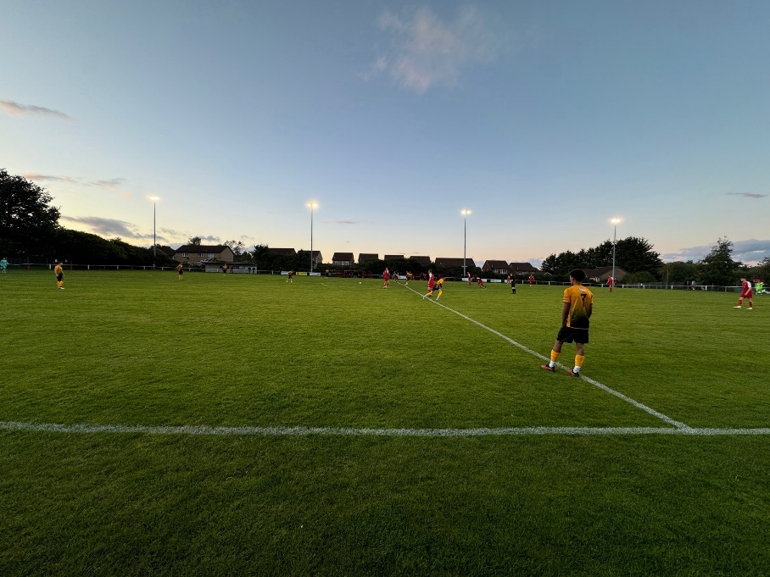
There was also plenty going on in the First Division, with ten fixtures encompassed across the two nights. That included Calne Town finally suffering their first league defeat of the campaign after conceding late on in a 2-1 loss at Longwell Green. Having fallen behind to Zac Tucker’s goal late in the first half, Calne got back on level terms shortly after half-time thanks to the prolific Josh Bright. Longwell Green have picked things up over recent weeks following a tough start, and they secured the impressive victory thanks to a 75th minute goal from Wilfred Cains. Bradford Town continued their strong run of form with Raphael Offong rifling home in their 2-0 win at Sturminster Newton, while Wells saw off the challenge of Odd Down, with Charlie Crook, Adam Wright and Charlie Moon all scoring in the first half of their 3-1 victory. That scoreline was also enough for Hallen to beat Mendip Broadwalk, although they did it the hard way, having to overcome an early deficit at the Hallen Centre. After Rhys Hickery had put the visitors in front after six minutes, Hallen hit back thanks to a quickfire double from Patryk Kosciolek and Elliot Gardner to go 2-1 up at the interval. A further goal at the beginning of the second half from Jack Askins added to the hosts lead, and they maintained that advantage throughout to secure another three points. There was also a home win for Gillingham, with Ryan Riglar scoring in either half of their 2-1 defeat of Warminster, while Bitton came out on top in a thrilling contest at home to Boco. It was Bitton who started fastest, forging ahead in the eighth minute thanks a back post finish from former Boco frontman Sacha Tong. A penalty late in the first half from Luke Bryan got the visitors back on level terms, and they then went 2-1 up after 48 minutes thanks to an own goal. That second Boco goal came just moments after Bitton were reduced to ten men, but that didn’t hold the hosts back, and after levelling through Keane Ashwood, they then turned the game back in their favour during the closing stages thanks to Tong who scored his second of the night. There was also plenty of goal-scoring action at Avonmouth, where the home side shared a 3-3 draw with Bristol Telephones. A pair of early goals from Matty Groves and Kyle O’Donovan had seen Avonmouth go two-up, but they were then pegged back in the opening stages of the second half following goals from the visiting duo of Craig Wilson and Archie Dark. It was the home side who went back in front thanks to O’Donovan’s second goal of the night, but his feat was equalled by Phones frontman Wilson who converted a late penalty to make it 3-3 to cap an entertaining evening’s action. 24 hours later, home teams went three from three, with Tyler Lane scoring a brace in Cadbury Heath’s 3-0 defeat of Keynsham (pictured, right). There was also another strong showing from Cribbs Reserves, with Aaron Coleman, Ollie Dunleavy and Liam Clayton all netting in their 3-1 victory over Cheddar. The other home winner was Shirehampton, with Ryan Radford’s early effort followed by goals in either half from recent addition Josiah McKayle, helping them beat Hengrove 3-1 in Bristol.

Premier Division: Buckland Athletic laid down an early season marker on Saturday, putting seven unanswered goals past Paulton to secure a huge victory. The game was in the balance for a while, before Buckland stormed ahead towards the end of the first half following a quickfire double from Ryan Smith and Owen Haslam. The home fans then had to wait for goal number three, with debutant Luke Forward prodding the ball home 20 minutes from time. The floodgates then opened during the final quarter of the game, with the Sam’s, Morcom and Stayt extending the lead to five, before Ryan Richards netted twice at the death to complete the scoring. Another side to have started strongly are Portishead, and they continued to flourish in their new surroundings by coming from behind to beat Saltash 4-1. A 13th minute effort from Jack Jefford had given the Ashes a dream start, but Town quickly turned things around with regular scorers Ethan Feltham and Ben Bament making it 2-1. Callum Eastwood then struck early in the second half to extend the advantage, with Bament converting a Mitch Osmond cross to wrap up the win. A couple of first half goals helped Bridgwater win 2-0 at St Blazey, with Brislington beating Ilfracombe by the same scoreline thanks to impressive finishes from both Ali Sen and Danny Constable. The standout result of the afternoon definitely came at Barnstaple, where the in-form hosts beat an undermatched Welton side by ten goals to nil. Josh Parry scored two goals in either half to cap an outstanding individual performance, with teammate Gabby Rogers also striking twice to maintain his excellent goalscoring run. Further goals came from Joe Grigg, Tommy Rogers, Brodie Montague and Cole Harford, with Town now sitting pretty in second spot thanks to their third win in a week. The only side placed higher on the ladder are Street, who remain at the top thanks to a tense 2-1 victory over St Austell. Having gone ahead in the tenth minute through Eli Collins, the Cobblers added to their lead early in the second half thanks to a Harry Foster spot kick. The away side then scored a penalty of their own, courtesy of Max Gilbert, but were unable to find an equaliser during the final 15 minutes and remain pointless from their four away games this term. One side who will be happy to have ended their long run of away matches are Wellington, and they will head into their upcoming run of home fixtures on the back of a morale-boosting 3-2 win at Torpoint. Having gone behind in just the third minute following a Harry Jeffery penalty, Welly got back on level terms 20 minutes from time thanks to a cross-come-shot from Sam Gleeson. The game wasn’t level for long however, and Jeffery found the back of the net for the second time to turn the game back in his side’s favour. Wellington’s Phil Mendonca then completely took over the contest, and after cooly slotting home for 2-2 in the 84th minute, he produced an excellent run and finish to give the away side a dramatic winner deep into stoppage time. There was also relatively late drama in Ivybridge, where the visiting Shepton Mallet edged to a 1-0 victory when Joel Sisson headed home Cam Allen’s whipped free-kick. In the only draw of the day, Oldland secured a point at Clevedon thanks a strong run and finish from Tom Blake midway through the second half. Elsewhere, it was a huge day for Nailsea & Tickenham, who were the Western League’s longest participants in this season’s FA Cup. Unfortunately, the Swags met their match in National League South outfit Chippenham Town, who won 6-1 at Fryth Way.
On the podcast this week, Ian catches up with Paulton’s Ray Johnston, who talks about their recent victory over Bridgwater and the work still required for his ambitious side. There is also a conversation with Shirehampton manager, Liam Greening, who gives an insight into their rebuilding process, as well as discussing the improvements he sees following the hard work completed last season at the club.
https://www.westernleague.co.uk/news/podcast-episode-7

First Division: Things continue to be incredibly tight in the top few positions, with Calne just about clinging onto first place despite drawing one apiece at Boco. Town were the better side during the opening 45 minutes and led by a goal to nil at the interval thanks to an Ackeem Stewart strike. Boco have started to pick up regular points over recent weeks, and that continued on Saturday, with Mickey Parsons heading home to claim a point off the league leaders. Level at the top with Calne are Hallen, and they had a brisk start away at Cheddar to secure a 2-0 victory. It looked like it would be a tough afternoon for the hosts when they fell two goals behind inside 20 minutes, but that was how it remained throughout, with Elliot Gardner and Jack Askins doing the damage for the South Gloucestershire outfit. There was also an impressive 2-0 win for Bitton, who played well throughout their defeat of Bradford Town. The Bobcats had won their previous three home fixtures, but came unstuck against their mid-table opponents who scored twice within the first 15 minutes of the second half through Jacob Saunders and Cody Vile to claim all three points. Devizes went one better, scoring three unanswered goals in their win at Shirehampton, with debutant Josh Parsons making an instant impact for his new side. Devizes forward Parsons struck twice for the visitors to help cap a strong showing, with the returning Luke Hooper also getting his name on the scoresheet in Portway. Levi Brown’s second half penalty helped Keynsham secure a 1-1 draw at Odd Down, while Hengrove beat Gillingham 3-0 thanks to goals from Ashton Burton, Sonny Parker and Brad Skidmore.
In one of the games of the day, Avonmouth battled back from a shocking start to beat Radstock 4-2 in Bristol. The away side had lost six on the bounce coming into the weekend’s game, but they shot out of the blocks at Avonmouth, going ahead in just the third minute thanks to a lobbed finish from Ben Wickens. It was Wickens’ heavy influence which then made it 2-0 after only ten minutes, with his goal-bound effort coming back off the post before deflecting into the net off a home defender. An own goal at the other end then gave Avonmouth an increased hope heading into the second half, and they didn’t wait long before getting on level terms with Zac Cheetham making it 2-2 from the spot. The turnaround was then complete 20 minutes from time courtesy of a Kyle O’Donovan goal, with Matt Curnock adding their fourth in stoppage time. There were also plenty of goals at Warminster, where the hosts held off the challenge of Cribbs Reserves to win 3-2. Goals either side of the interval from Jack Newman and Sam McFarlane had put Town in a position of strength, which was soon trimmed when Liam Clayton tucked home a penalty for the away side. Newman then struck again 15 minutes from time to restore the two-goal advantage, and that ended up being crucial after Aaron Coleman netted in the closing stages for the visiting Cribbs side. Elsewhere, it was a strong showing from the away teams, including Bristol Telephones, with Jamie Noble’s double helping them win 3-1 at Longwell Green. Finn Burnell had cancelled out the Phones half-time lead when he struck early in the second half, but it was the visitors who ended the day on top with Noble and Isaac Flynn scoring one apiece during the final ten minutes. 3-1 was also the final score in Sturminster’s win at Mendip Broadwalk, with United completing a second half comeback at Creswicke Road. Having handed their hosts an early lead via an own goal, Sturminster battled back, eventually running out comfortable winners, with Billy Bright, Harry Smith and Elliot Bevis all netting during the victory. Fourth-placed Wells also won on their travels, with Craig Herrod scoring a brace in their 4-2 defeat of Cadbury Heath. City’s away form had been a cause for concern this season, but they managed to capture their first road victory, with Herrod’s double adding to further goals from Charlie Moon and Tom Smith and helping them come out on top in the top-six battle at Springfield.
Recent Results
Tuesday 10th September 2024
Premier Division
Bridgwater United 1-3 Barnstaple Town
Brislington 6-0 Welton Rovers
Brixham 2-0 St Austell
Ilfracombe Town 0-3 Saltash United
Oldland Abbotonians 4-0 Nailsea & Tickenham
Paulton Rovers 0-1 Street
Shepton Mallet 5-1 Wellington
First Division
Avonmouth 3-3 Bristol Telephones
Bitton 3-2 AEK Boco
Gillingham Town 2-1 Warminster Town
Hallen 3-1 Mendip Broadwalk
Longwell Green 2-1 Calne Town
Sturminster Newton 0-2 Bradford Town
Wells City 3-1 Odd Down
Wednesday 11th September 2024
Premier Division
St Blazey 0-2 Ivybridge Town
First Division
Cadbury Heath 3-0 Keynsham Town
Cribbs Reserves 3-1 Cheddar
Shirehampton 3-1 Hengrove Athletic

Saturday 14th September 2024
FA CUP – Second Round Qualifying
Nailsea & Tickenham 1-6 Chippenham Town
Premier Division
Barnstaple Town 10-0 Welton Rovers
Brislington 2-0 Ilfracombe Town
Buckland Athletic 7-0 Paulton Rovers
Clevedon Town 1-1 Oldland Abbotonians
Ivybridge Town 0-1 Shepton Mallet
Saltash United 1-4 Portishead Town
St Blazey 0-2 Bridgwater United
Street 2-1 St Austell
Torpoint Athletic 2-3 Wellington
First Division
AEK Boco 1-1 Calne Town
Avonmouth 4-2 Radstock Town
Bradford Town 0-2 Bitton
Cadbury Heath 2-4 Wells City
Cheddar 0-2 Hallen
Hengrove Athletic 3-0 Gillingham Town
Longwell Green Sports 1-3 Bristol Telephones
Mendip Broadwalk 1-3 Sturminster Newton
Odd Down 1-1 Keynsham Town
Shirehampton 0-3 Devizes Town
Warminster Town 3-2 Cribbs Reserves
Upcoming Fixtures
Tuesday 17th September 2024
Premier Division
Bridgwater United vs Shepton Mallet 19:45KO
Brixham vs Saltash United 19:30KO
Ilfracombe Town vs St Blazey 19:45KO
Nailsea & Tickenham vs Brislington 19:30KO
Oldland Abbotonians vs Street 19:30KO
Paulton Rovers vs Clevedon Town 19:30KO
Welton Rovers vs Portishead Town 19:30KO
First Division
Bristol Telephones vs Hengrove Athletic 19:45KO
Calne Town vs Cadbury Heath 19:45KO
Cheddar vs Avonmouth 19:45KO
Gillingham Town vs Wells City 19:30KO
Keynsham Town vs Bitton 19:45KO
Odd Down vs Hallen 19:45KO
Radstock Town vs Longwell Green Sports 19:45KO
Sturminster Newton vs Warminster Town 19:45KO

Wednesday 18th September 2024
Premier Division
AFC St Austell vs Buckland Athletic 19:30KO
Ivybridge Town vs Torpoint Athletic 19:30KO
Wellington vs Barnstaple Town 19:45KO
First Division
Cribbs Reserves vs AEK Boco 19:45KO
Shirehampton vs Mendip Broadwalk 19:45KO

Saturday 21st September 2024 (3pm Kick-off unless noted otherwise)
Premier Division
AFC St Austell vs Bridgwater United
Barnstaple Town vs Clevedon Town
Shepton Mallet vs Saltash United
Street vs Brixham
First Division
Avonmouth vs Gillingham Town
Mendip Broadwalk vs AEK Boco

FA Vase Second Round Qualifying
AFC Aldermaston vs Bradford Town
Berks County vs Brislington
Bishops Lydeard vs Radstock Town
Bitton vs Tuffley Rovers
Bristol Telephones vs Tadley Calleva
Buckland Athletic vs Callington
Devizes Town vs Slimbridge
Honiton vs Torpoint Athletic
Ilfracombe Town vs Bovey Tracey
Longwell Green Sports vs Portishead Town
Lydney Town vs Oldland Abbotonians
Milton United vs Hengrove Athletic
Paulton Rovers vs Torridgeside
Shortwood United vs Cadbury Heath
Sturminster Newton vs Infinity FC
Wellington vs Sidmouth Town
Welton Rovers vs Nailsea & Tickenham
Wendron United vs St Blazey

League Tables

 | PREMIER DIVISION | Played | Won | Drawn | Lost | GD | Points
1 | Street | 9 | 7 | 2 | 0 | 10 | 23
2 | Barnstaple Town | 9 | 7 | 1 | 1 | 19 | 22
3 | Brislington | 10 | 7 | 0 | 3 | 18 | 21
4 | Clevedon Town | 9 | 6 | 2 | 1 | 21 | 20
5 | Portishead Town | 9 | 6 | 2 | 1 | 10 | 20
6 | Buckland Athletic | 8 | 6 | 1 | 1 | 22 | 19
7 | Bridgwater United | 10 | 5 | 1 | 4 | -3 | 16
8 | Nailsea & Tickenham | 7 | 5 | 0 | 2 | 5 | 15
9 | Paulton Rovers | 9 | 5 | 0 | 4 | -2 | 15
10 | Brixham AFC | 8 | 3 | 4 | 1 | 7 | 13
11 | Oldland Abbotonians | 9 | 4 | 1 | 4 | 4 | 13
12 | Ivybridge Town | 9 | 4 | 1 | 4 | 0 | 13
13 | Shepton Mallet | 9 | 3 | 3 | 3 | 4 | 12
14 | Wellington | 10 | 3 | 0 | 7 | -13 | 9
15 | Ilfracombe Town | 11 | 2 | 2 | 7 | -9 | 8
16 | Saltash United | 10 | 2 | 2 | 6 | -10 | 8
17 | St Blazey | 9 | 2 | 2 | 5 | -10 | 8
18 | AFC St Austell | 9 | 2 | 0 | 7 | -8 | 6
19 | Torpoint Athletic | 10 | 1 | 0 | 9 | -19 | 3
20 | Welton Rovers | 10 | 0 | 0 | 10 | -46 | 0

 | FIRST DIVISION | Played | Won | Drawn | Lost | GD | Points
1 | Calne Town | 11 | 8 | 2 | 1 | 16 | 26
2 | Hallen | 11 | 8 | 2 | 1 | 16 | 26
3 | Bradford Town | 10 | 8 | 0 | 2 | 14 | 24
4 | Wells City | 12 | 7 | 2 | 3 | 13 | 23
5 | Avonmouth | 13 | 6 | 2 | 5 | 6 | 20
6 | Cadbury Heath | 11 | 6 | 2 | 3 | 3 | 20
7 | Bristol Telephones | 11 | 6 | 1 | 4 | 10 | 19
8 | Shirehampton | 10 | 6 | 1 | 3 | 7 | 19
9 | Cribbs Reserves | 13 | 6 | 1 | 6 | 3 | 19
10 | Bitton | 11 | 6 | 1 | 4 | 2 | 19
11 | Devizes Town | 10 | 5 | 3 | 2 | 14 | 18
12 | Sturminster Newton United | 11 | 5 | 2 | 4 | 4 | 17
13 | Longwell Green Sports | 11 | 5 | 2 | 4 | 0 | 17
14 | Mendip Broadwalk | 12 | 4 | 3 | 5 | -9 | 15
15 | Warminster Town | 11 | 3 | 3 | 5 | -7 | 12
16 | Keynsham Town | 11 | 3 | 3 | 5 | -12 | 12
17 | AEK Boco | 12 | 3 | 1 | 8 | -5 | 10
18 | Odd Down | 12 | 2 | 4 | 6 | -6 | 10
19 | Hengrove Athletic | 11 | 2 | 2 | 7 | -11 | 8
20 | Radstock Town | 10 | 2 | 0 | 8 | -11 | 6
21 | Cheddar | 11 | 1 | 2 | 8 | -19 | 5
22 | Gillingham Town | 11 | 1 | 1 | 9 | -28 | 4

