

#5

Latest Round-ups:
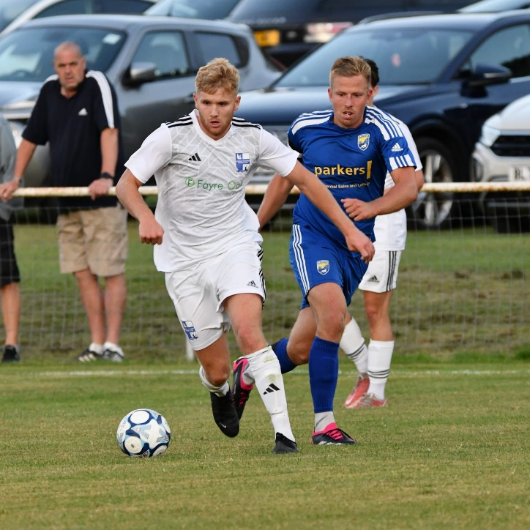
Midweek Action: There were mixed results on Tuesday evening, with a quick turnaround seeing a pair of FA Cup Preliminary Round fixtures taking place. It was success for Nailsea & Tickenham, who snuck past Reading City by the skin of their teeth at Fryth Way (pictured, in action, right). After an entertaining draw three days earlier, it looked as though the sides would level once again with the game heading into stoppage time locked at nil-nil. The Swags had one final chance from a set-piece, and after the loose ball fell to Miles Hardidge inside the area, he unleashed a fearsome strike into the top corner to claim the dramatic victory, booking their spot in the first qualifying round for the first time in their history. Unfortunately, Wellington fell at the same hurdle, losing 2-0 to Bideford following goals from Finn Roberts and Jordan Ewing. 24 hours later, Brixham pulled off an impressive victory away at Southern League outfit, Exmouth Town. After the original tie had been abandoned on Saturday afternoon, Brixham travelled back up the coast on Wednesday, and booked their spot in the next round thanks to a pair of first-half efforts from Reece Somers and James Moxon.

On the latest episode of the podcast, we hear from Barnstaple Town boss Ben Potter, who looks back on their impressive start to the campaign. Ben credits the passionate support they receive, while also touching on the rebuilding job underway at the club. Ian is also joined by Hallen’s Karl Baggaley, who explains why the believes the quality of the First Division is as good as its ever been.
https://www.westernleague.co.uk/news/podcast-episode-5

FA Vase: It was a busy few days of Vase action, starting on Friday night, when Ivybridge won 2-0 away at Newton Abbot Spurs. First half goals from Rory Busby and Chris Wright proved to be enough for Town, who put their tough league form behind them to progress. Elsewhere that evening, Nailsea & Tickenham couldn’t follow up their impressive FA Cup win earlier in the week, and fell to a heavy 4-1 defeat in North Somerset against Sandhurst.
A bumper Saturday afternoon of single-match knockout clashes included several top results for Western League sides, with Buckland claiming a 3-1 win at Crediton United. Goals late in the first half from Jared Lewington and Sam Morcom gave the away side a strong foothold, with Ryan Bush then wrapping things up in the closing stages. Cadbury Heath also progressed from the first round of qualifying thanks to a 3-1 win at Newent. A strong first half proved to be the difference between the sides, with Dan Winstone and Ash Kendall firing them into a two-goal advantage. Josh Williams then added the Heath’s third late in the opening period, taking advantage of their hosts being reduced to eight men at the time. Sturminster Newton were another side who were successful on their travels, with Nick Hewlett’s brace leading them to a 3-2 win at Folland Sports. The other big winner was Bitton, who held off a charge from hosts Wantage to win by four goals to two. A pair of first half goals from Adey Harvey sandwiched an Ash McGrane effort, helping the away side build a three-goal advantage. Wantage then attempted a comeback, scoring their second goal 20 minutes from time, but Bitton did enough to progress, with Sacha Tong’s injury time header putting an end to the contest. Tougher afternoons were endured by both Keynsham and Cheddar who fell to 5-1 defeats, while Warminster were beaten 3-1 at Hamworthy United despite levelling early on through Jack Newman. Street are another side who will be disappointed to have fallen at the first hurdle, with their winning run in the league not mirrored in the Vase where they were defeated 3-2 by Elburton Villa. Goals from both Connor and Dan Linham kept the Cobblers in contention throughout, but they then conceded in the final 15 minutes as Villa booked their spot in the next round.
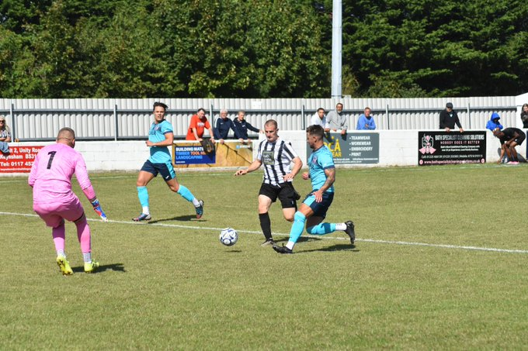
Joining Elburton in the second round of Qualifying late in September will be St Blazey who toppled Saltash in one of the all-Western League clashes. It was the Ashes who started fastest, and they went ahead after only 15 minutes through Jack Wood. Jacob Rowe then levelled affairs late in the first half, with Ryan Downing netting shortly after to put the hosts 2-1 up at the interval. That was how it remained for the majority of the second half, with St Blazey finally wrapping things up in the 93rd minute when Jayden Gilbert adding their third of the afternoon. Premier Division leaders Brislington won 2-0 at Odd Down, with Oaklan Buck and Joe McLennan each scoring after the interval on a windy afternoon in Bath (pictured, right).

The other two matches were tight tussles, both decided on penalties, with Portishead and Hengrove squeaking through. For Portishead, they had keeper Ryan Thacker to thank in their win at Hallen, with a penalty save during normal time, then followed by two more during the shootout. Two goals inside the opening 12 minutes from Callum Eastwood and Kyle Egan made it look like Town might be afforded a comfortable afternoon. That wasn’t the case however, and Lewis Saunders kept up his strong start to the campaign by pulling a goal back ten minutes before half-time. Thacker then thwarted Cory Thomas-Barker from the spot just three minutes later, but Hallen didn’t have to wait too long before getting on level terms, with Saunders chipping the ball home just before the game reached the hour mark. It remained two-apiece throughout, and with the game going straight to penalties, Ethan Feltham stepped up to fire home the winner from 12 yards thanks to a starring role from his goalkeeper. Hengrove were the others to enjoy a shootout victory, knocking out Shirehampton after the game had finished one-all after 90 minutes. Pete Sheppard’s first half strike looked like it would be enough for the Grove, but they were denied a victory in normal time due to Anele Nkubee’s stoppage time equaliser. That setback didn’t deter the home side however, and they rebounded strongly to win 4-3 on penalties. Unfortunately for Shepton Mallet, they were knocked out on penalties, drawing 1-1 at Callington, before losing 5-4 in the shootout. Ending of a positive note from Saturday’s games, Oldland Abbotonians claimed a 1-0 win at home to Cirencester following some late drama. With the game seemingly headed for a stalemate, Abbots forward Owen McCallum was sent on with eight minutes remaining, and made an immediate impact, knocking the ball home to help his side claim a one-goal victory. Then, on Sunday, a young Calne side were heavily beaten by Berks County. The hosts only led 1-0 at the interval, but finished strongly at the Racecourse Ground in Ascot, eventually winning by six goals to one. Nat Bell had threatened to kick-start a second half fightback for the Lilywhites, but it wasn’t to be, and their Vase participation ended at the first hurdle.
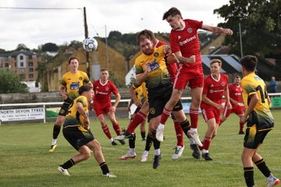
League Action: Among the form sides in the Premier Division are Barnstaple Town, with the Devonians securing their fifth win in the space of 18 days thanks to a 3-2 defeat of Torpoint. After falling behind to Mason Elliot’s early opener, Barnstaple turned things around thanks to a long-ranger from Ricky Marinaro and a scrappy Josh Parry tap-in. Opponents Torpoint have had their early season struggles, but it looked like they had done enough to claim a late point, with Luke Cloke heading home to make it 2-2 late in the piece. Barnstaple weren’t ready to be denied however, and thanks to another wicked Gabby Rogers corner, the ball found its way to Marinaro who tucked the ball home to put his side back in front during added time.

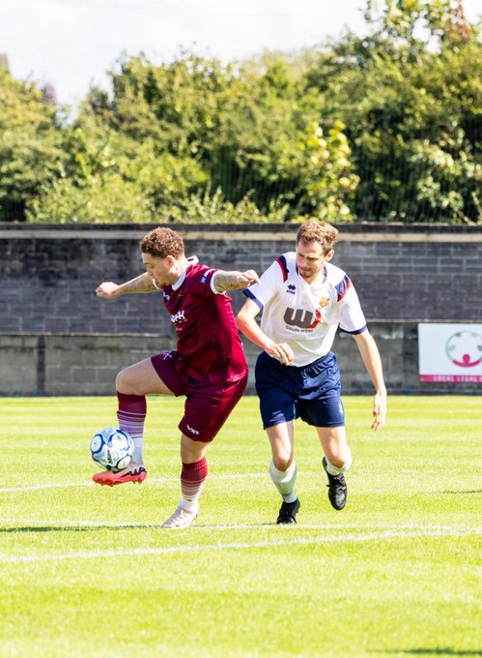
Another high-scoring fixture took place at the Winterfield Stadium, who Kye Simpson’s crucial double helped Paulton beat Wellington 4-2 (pictured, left). A strong end to the first half saw Paulton pull ahead, with Jack Farion’s header followed shortly after by Simpson’s first goal of the afternoon. In-form Wellington forward Miles Quick reduced the arrears shortly after the break, with Dan McBeam then striking 20 minutes from time to put Rovers two in front. It was another goal from Quick which set up the nervy finale, but the hosts had enough in the tank, scoring again through Simpson to restore the advantage and hold on for maximum points. Ilfracombe finally claimed their first league win of the campaign, storming to a 4-0 victory at home to Welton thanks to a devastating second-half performance. It took over 65 minutes for Chris Roberts to break the deadlock, but once he did, Town were irresistible, thanks to further goals in the final quarter from Harry Taffs, Lewis Cornish and finally, skipper, Jack Jenkins. Goals were harder to come by at Fairfax Park where Bridgwater and Brixham battled out a goalless draw, but were very much in demand down in Cornwall where Clevedon put five past hosts, AFC St Austell. In similar fashion to Paulton, the Seasiders struck twice in the dying embers of the first half to go 2-0 up, with Freddie King scoring a quickfire double. Kyle Marks then struck at the beginning of the second half to get St Austell on the board, yet they were soon back two behind following a strong Harrison Coker finish. Further goals from Andrew Collings and Sam Beresford soon put Clevedon out of sight, with Liam Eddy heading home a late consolation in a tough 5-2 defeat for the hosts.
There were also a couple of one-sided outings in the First Division on Saturday afternoon, including Wells City’s 6-0 trouncing of Gillingham Town. An Adam Wright hat-trick was the main factor in Wells’ big win, with Craig Herrod also notching a brace for the home side. Devizes finally suffered defeat, seeing Fin Burnell and Zac Feltham both find the back of the net during Longwell Green’s 2-0 victory at Shellards Road. Two-nil was also the winning margin for Bradford Town in their triumph over Radstock, with a sixth-straight league victory helping to take them up into top spot. A dream start to the encounter saw Bradford go ahead after just 30 seconds, with Sam Jordan heading into the Radstock net as the hosts made their first forward foray. It was then a 65th minute effort from Callum Demkiv which wrapped things up for the home side who have scored at least twice in all six of their victories this term. The second hat-trick hero residing in the First Division was Luke Bryan, with the Boco forward helping his side overturn an early deficit in their 4-1 win over Mendip Broadwalk. In a breakneck start to the game, Bryan levelled affairs after only ten minutes, with home keeper Nick Croucher then saving a Mendip penalty shortly after to keep the game locked at one apiece. Bryan then scored his second to put Boco ahead, finally completing his treble in the closing stages after another goal from Mickey Parsons. There was also a fixture on Friday evening, with the improving Cribbs Reserves winning 2-0 at Avonmouth. Having lost their opening five games, Cribbs have won seven points in the space of ten days, with goals from Tom Headford and Liam Clayton either side of the interval helping them move into the top half.
Recent Results
Tuesday 20th August 2024
FA Cup Preliminary Round
Nailsea & Tickenham 1-0 Reading City
Wellington 0-2 Bideford

Wednesday 21st August 2024
FA Cup Preliminary Round
Exmouth Town 0-2 Brixham

Friday 23rd August 2024
FA Vase First Round Qualifying
Newton Abbot Spurs 0-2 Ivybridge Town
Sandhurst 4-1 Nailsea & Tickenham
First Division
Avonmouth 0-2 Cribbs Reserves 208

Saturday 24th August 2024
FA Vase First Round Qualifying
Callington 1-1 (5-4 pens) Shepton Mallet
Crediton United 1-3 Buckland Athletic
Folland Sports 2-3 Sturminster Newton United
Hallen 2-2 (1-3 pens) Portishead Town
Hamworthy United 3-1 Warminster Town
Hengrove Athletic 1-1 (4-3 pens) Shirehampton
Newent 1-3 Cadbury Heath
Odd Down 0-2 Brislington
Oldland Abbotonians 1-0 Cirencester
St Blazey 3-1 Saltash United
Street 2-3 Elburton Villa
Tytherington Rocks 5-1 Keynsham Town
Wadebridge Town 5-1 Cheddar
Wantage 2-4 Bitton
Premier Division
AFC St Austell 2-5 Clevedon Town
Barnstaple Town 3-2 Torpoint Athletic
Bridgwater United 0-0 Brixham
Ilfracombe Town 4-0 Welton Rovers
Paulton Rovers 4-2 Wellington
First Division
AEK Boco 4-1 Mendip Broadwalk
Bradford Town 2-0 Radstock Town
Longwell Green Sports 2-0 Devizes Town
Wells City 6-0 Gillingham Town
Sunday 25th August 2024
FA Vase First Round Qualifying
Berks County 6-1 Calne Town
Upcoming Fixtures
Tuesday 27th August 2024
Premier Division
Bridgwater United vs Portishead Town 19:45KO
Brixham AFC vs St Blazey 19:30KO
Brislington vs Nailsea & Tickenham 19:45KO
Buckland Athletic vs AFC St Austell 19:30KO
Paulton Rovers vs Shepton Mallet 19:30KO
Saltash United vs Ilfracombe Town 19:45KO
Street vs Barnstaple Town 19:45KO
Torpoint Athletic vs Ivybridge Town 19:30KO
First Division
Gillingham Town vs Cheddar 19:45KO
Hallen vs Avonmouth 19:30KO
Hengrove Athletic vs Bitton 19:30KO
Odd Down vs AEK Boco 19:45KO
Radstock Town vs Keynsham Town 19:45KO
Wells City vs Sturminster Newton United 19:30KO
Wednesday 28th August 2024
Premier Division
Clevedon Town vs Wellington 19:30KO
First Division
Shirehampton vs Cribbs Reserves 19:45KO
Warminster Town vs Mendip Broadwalk 19:45KO
Saturday 31st August 2024 (3pm Kick-off unless noted otherwise)
FA Cup First Round Qualifying
Barnstaple Town vs Larkhall Athletic
Gloucester City vs Paulton Rovers
Hartpury University vs Nailsea & Tickenham
Willand Rovers vs Brixham AFC
Premier Division
AFC St Austell vs Portishead Town
Bridgwater United vs Wellington
Brislington vs Ivybridge Town
Buckland Athletic vs Saltash United
Clevedon Town vs Ilfracombe Town
Shepton Mallet vs Oldland Abbotonians
St Blazey vs Welton Rovers
Street vs Torpoint Athletic
First Division
Avonmouth vs Bitton
Calne Town vs Wells City
Cribbs Reserves vs Cadbury Heath
Devizes Town vs Bristol Telephones
Hallen vs Bradford Town
Keynsham Town vs AEK Boco
Longwell Green Sports vs Odd Down
Mendip Broadwalk vs Cheddar
Shirehampton vs Gillingham Town
Sturminster Newton United vs Hengrove Athletic
Warminster Town vs Radstock Town


