

#6

Latest Round-ups:
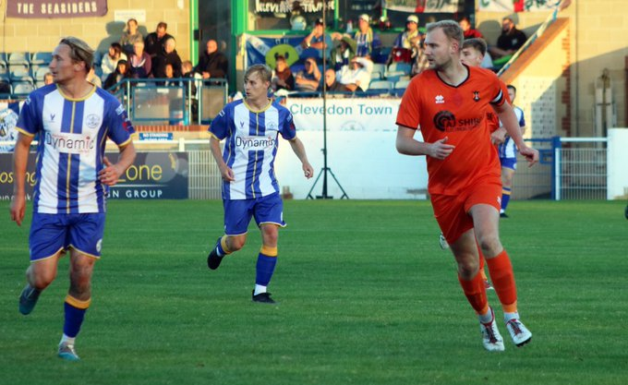
Midweek Action: Brislington were handed their first defeat in the Premier Division on Tuesday, going down to a 2-0 loss at home to Nailsea & Tickenham. Having scored at least twice in all their previous fixtures, Bris were held at bay by the Swags backline, with a pair of quickfire goals during the first half from Shea Mannings and Lucas Vowles leading the visitors to victory. Another impressive away win that night saw Portishead Town secure a 3-1 victory at Bridgwater. Town’s start to life in the top division has been really impressive, and they flew out of the blocks on Tuesday, leading 2-0 inside 15 minutes thanks to goals from Kyle Egan and Ethan Feltham. The second half started well for the hosts who pulled a goal back through Fin Koppa, but Portishead managed to strike again through leading frontman Feltham to claim another away win. Paulton Rovers overcame local rivals Shepton Mallet in an entertaining five-goal encounter played in front of a strong midweek crowd. Having gone in front courtesy of a Josh Ford header, Paulton doubled their lead on the half hour thanks to a poked finish from Will Osborne. Shepton looked to have given themselves a boost going into the break when Josh Jenkins reduced the arrears, but Rovers hit back instantly through Osborne to maintain their two-goal advantage. Jenkins struck again for the visitors to set up a grandstand finish, but Paulton managed to hang on, completing the double over Shepton having won 2-1 in the reverse fixture a fortnight previously. Down in Cornwall, Ilfracombe secured their second league win of the season after beating Saltash 4-1. Having gone ahead through Jamie Hearsey, Town were pegged back by their hosts in first half stoppage time when Kieran O’Melia made it one apiece. Ilfracombe’s Lewis Cornish then took over the contest, scoring twice to put some distance between the sides, with Billy Tucker wrapping things up in the closing stages. Another forward to score twice that evening was Jared Lewington, with the Buckland star scoring in either half of his side’s 2-0 victory at home to St Austell. Josh Parry scored a second half equaliser for Barnstaple in their 1-1 draw at Street, while Brixham and St Blazey battled out a goalless stalemate. Elsewhere, Ivybridge grabbed their first league win of the campaign after beating fellow slow-starters Torpoint 3-0. A couple of late goals from Sean Thomson and Rory Busby helped complete Town’s win, following up their impressive Vase triumph last weekend. On Wednesday, Freddie King’s excellent individual effort kickstarted Clevedon’s 3-0 win over Wellington. King beat four defenders before firing home to make it 1-0 late in the first half, with further goals after the interval from Sam Beresford and Kieran Ireland helping to complete the victory.
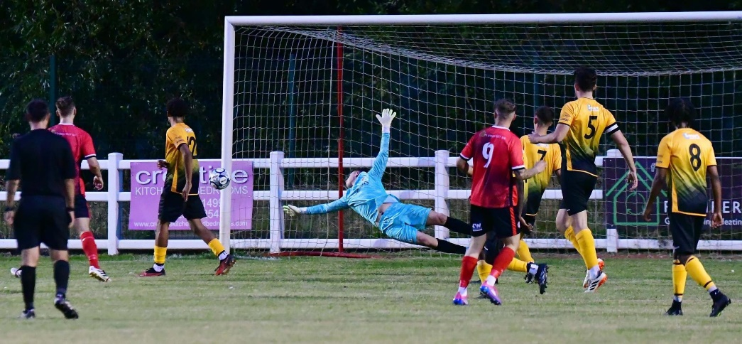
It was a good night for sides who have had early struggles in the First Division, including Keynsham who won 2-1 at Radstock. Following a goalless opening half, the K’s went ahead five minutes after the interval thanks to a Riley Hobbs effort. The hosts then hit back less than two minutes later through Jacob Bird, but Keynsham managed to find a second wind, going back ahead in the closing stages thanks to an acrobatic finish from Kaylen Edwards.
Cheddar ended a six-match winning run, coming from behind to beat Gillingham 2-1. In an early season basement battle, it was the home side who made the first move, breaking the deadlock after half an hour through Josh Josey. With only 20 minutes left on the clock, Morgan Bacon managed to level affairs, with the Cheesemen securing all three points thanks to an 84th minute winner from Tom Davies. At the opposite end of the table, Charlie Crook’s second half brace led Wells to a 2-0 win over Sturminster Newton, while goals from Elliot Gardner and Patryk Kosciolek helped Hallen beat local rivals Avonmouth by the same scoreline. In the only draw of the evening, Ash McGrane cancelled out Oscar Sullivan’s opener to help Bitton claim a point at Hengrove, while in Bath, former Odd Down striker Luke Bryan grabbed a hat-trick to help his current side Boco secure a 5-3 win. It wasn’t a comfortable evening for the visitors who trailed 2-1 at the break following goals from Alfie Andrews and Dom Walter. Bryan then slotted home a penalty on the hour mark to make it 2-2, before he struck again in the 69th minute to complete his hat-trick. Further goals from Mickey Parsons and Romiah Nevers extended Boco’s lead further, with Odd Down claiming a stunning consolation goal in added time through Nathan Hall. Cribbs Reserves continued their recent resurgence on Wednesday evening by claiming a 2-0 win away at Shirehampton. A superb free-kick from Aaron Coleman handed the visitors a half-time lead, which was then added to shortly after the interval by Jack Guthrie, giving Cribbs 13 points from their last five games. The other game that night went the way of Mendip Broadwalk who claimed their first away win of the campaign by beating Warminster 3-1 thanks to goals from Rhys Hickery, Mason Daggar and Dylan Whittle.
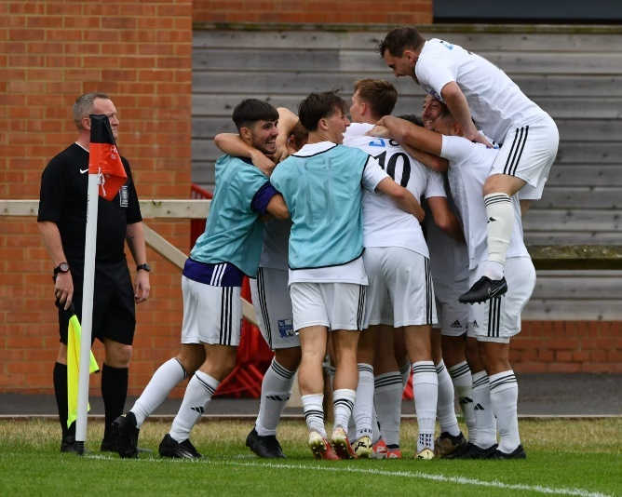
FA Cup: Nailsea & Tickenham produced more cup heroics to qualify for the second round of qualifying following a 2-0 win away at Hartpury University. After a goalless opening half, the Swags went ahead shortly after the interval with Lucas Vowles adding to his midweek effort. Nailsea had to repel a number of home attacks, and having done so, they then doubled their advantage in added time through Connor Saunders (pictured, celebrating, right). It was an unfortunate afternoon for the remainder of the Western League sides who were all knocked out by higher-ranked opposition. That included Brixham who fell to a slender 1-0 defeat at Willand, while Paulton conceded twice in the first half on their way to a 2-0 loss in Gloucester. For Barnstaple, their late attempts at a comeback fell just short, with Larkhall coming away with the 2-1 win. Two second half strikes Eben Mortimer-Taylor and Lewis Graham had put the Bath side in front, with a late Callum Deemer goal proving too little too late for a gallant Town side.
Premier Division: In one of the early season surprises, Ivybridge Town toppled previous league leaders Brislington by two goals to nil at Ironmould Lane. Having also fallen to a home defeat during the week, Bris made the worst possible start on Saturday afternoon after conceding to Rio Daly in just the 7th minute. Town keeper Kane Gregory then saved an Asa White penalty to keep the home side from levelling, with a late goal from Ivies forward Sam Hillson completing the victory. Currently sitting in top spot after a month’s worth of action are Portishead, with the promoted outfit storming to a 3-1 win at St Austell in their latest triumph. The game was pretty much done and dusted by half-time in Cornwall, with Ben Bament and Ethan Feltham both assisting goals for one another, before then being heavily involved in the build-up for Kyle Egan who made it 3-0 after just 35 minutes. The hosts did manage to grab a late consolation through Matt Searle, but didn’t have enough to stop them suffering their third loss of the week. It was a better afternoon for another Cornish outfit in St Blazey who finished strongly to beat Welton 3-1. After their early opener from Jayden Gilbert had been cancelled out by a Welton penalty, the hosts went back in front courtesy of George Newton, before then wrapping up victory with a lobbed finish from Noah Maund. Up in Somerset, Bridgwater beat local rivals Wellington 1-0 thanks to a 52nd minute header from Jamie Price, while Alessandro Costanza struck a double to help lead Street to a 2-1 defeat of Torpoint at the Tannery Ground. The biggest winners of the day were Clevedon who scored four second half goals in their 5-0 victory at home to Ilfracombe. A Freddie King goal was all that separated the sides at the interval, with the Seasiders then pulling clear thanks to further efforts from Alex Camm, Joe Teall, Sam Beresford and Harrison Coker. Alongside Clevedon towards the top are Buckland who also secured their fifth win after seeing off Saltash by three goals to one at Homers Heath. A fast start for the Bucks saw off-season addition Ryan Richards maintain his strong start to the campaign by netting in the 7th minute with a low, driven finish. Jared Lewington then headed the hosts two in front on the cusp of half-time, before substitute James Rowe stretched the lead out further, not long after coming on for the injured Richards. A goal early in the second half from Deacon Thomson threatened to spark a comeback, but the Ashes couldn’t make further inroads and remain rooted on two points from seven games.
Early season struggles also seem to be holding back Shepton Mallet, who remain with just one victory following a 3-1 home defeat at the hands of Oldland Abbotonians. In a game involving 15 yellow cards, and both sides being reduced to ten men, it was the visitors who came out on top thanks to a pair of penalties. Dylan Gould tucked home a penalty of his own to level for Shepton, but Oldland pulled away after the interval to make it three wins on the bounce in all competitions.
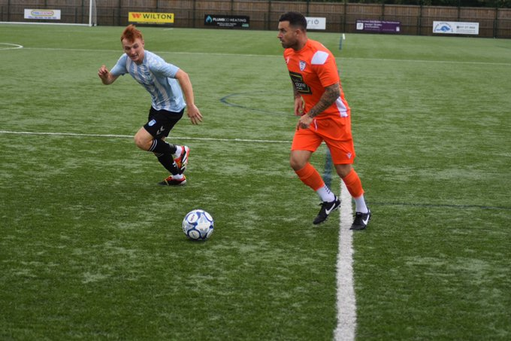
First Division: Hallen became the first side to reach the 20-point mark this term after coming out on top in an enthralling five-goal encounter with Bradford. Early pressure paid off for the home side for whom Cory Thomas-Barker made it 1-0, only for the Bobcats to hit back instantly through Jacob Mead to cap a rip-roaring start. The goal action didn’t slow down whatsoever, and after re-taking the lead through Elliot Gardner, Hallen were pegged back again just before the half-hour mark, with Jordan Pinder rolling home a spot kick for 2-2. Things then went awry for he hosts early in the second half when they lost Noah Blundell to a red card, but the ten-men regrouped and managed to find a dramatic winner with Gardner scoring his second of the contest. In a similarly entertaining clash, Cadbury Heath twice battled back from behind, before eventually beating Cribbs Reserves 3-2. Two goals from Archie Lock and Jack Guthrie had put the hosts ahead on separate occasions during a non-stop first half, with the Heath responded thanks to goals of their own from Hassan Hussein and then Miles Scott. It remained two-apiece all the way until the fifth minute of second half stoppage time when Josh Williams stepped up to convert a nerveless penalty to claim maximum points in dramatic fashion. It was a more comfortable afternoon for a pair of recent Western League additions, with Mendip Broadwalk beating strugglers Cheddar by two goals to nil. After going in front thanks to a Dylan Whittle header late in the first half, Mendip pulled clear with 20 minutes left on the clock when debutant Micky Gough netted after coming off the bench. Sturminster Newton also secured three points, with an Ash Clarke double followed up by a Nick Hewlett header in their 3-0 defeat of Hengrove. Away wins were a rarer beast on Saturday afternoon, with Archie Dark’s solitary goal helping Bristol Telephones sneak past Devizes, while Bitton’s Sacha Tong scored a crucial brace in their 2-1 win at Avonmouth. Having broken the deadlock after 13 minutes, Tong was relied upon to bag a late winner after Avonmouth’s Cody Winkler had levelled affairs midway through the second half. There was a 2-0 win for Longwell Green over Odd Down thanks to first half goals from Zach Feltham and Billy Hensler, with the same scoreline helping Warminster down Radstock. Having gone ahead after 16 minutes via the head of Sam Roberts, Warminster missed out on the chance to double their lead following a penalty save from visiting keeper Tom Crouch. The hosts weren’t kept at bay for long however, and the crucial second goal came on the stroke of half time through Jake Wright. Elsewhere, Kamal Yasin scored in either half of Keynsham’s 2-1 win over Boco, while Pat Collier, Nat Bell and Stu Windsor all scored after the interval in Calne’s 3-0 victory at home to Wells.

Recent Results
Tuesday 27th August 2024
Premier Division
Bridgwater United 1-3 Portishead Town
Brislington 0-2 Nailsea & Tickenham
Brixham AFC 0-0 St Blazey
Buckland Athletic 2-0 AFC St Austell
Paulton Rovers 3-2 Shepton Mallet
Saltash United 1-4 Ilfracombe Town
Street 1-1 Barnstaple Town
Torpoint Athletic 0-3 Ivybridge Town
First Division
Gillingham Town 1-2 Cheddar
Hallen 2-0 Avonmouth
Hengrove Athletic 1-1 Bitton
Odd Down 3-5 AEK Boco
Radstock Town 1-2 Keynsham Town
Wells City 2-0 Sturminster Newton United
Wednesday 28th August 2024
Premier Division
Clevedon Town 3-0 Wellington
First Division
Shirehampton 0-2 Cribbs Reserves
Warminster Town 1-3 Mendip Broadwalk

Saturday 31st August 2024
FA Cup First Round Qualifying
Barnstaple Town 1-2 Larkhall Athletic
Gloucester City 2-0 Paulton Rovers
Hartpury University 0-2 Nailsea & Tickenham
Willand Rovers 1-0 Brixham AFC
Premier Division
AFC St Austell 1-3 Portishead Town
Bridgwater United 1-0 Wellington
Brislington 0-2 Ivybridge Town
Buckland Athletic 3-1 Saltash United
Clevedon Town 5-0 Ilfracombe Town
Shepton Mallet 1-3 Oldland Abbotonians
St Blazey 3-1 Welton Rovers
Street 2-1 Torpoint Athletic
First Division
Avonmouth 1-2 Bitton
Calne Town 3-0 Wells City
Cribbs Reserves 2-3 Cadbury Heath
Devizes Town 0-1 Bristol Telephones
Hallen 3-2 Bradford Town
Keynsham Town 2-1 AEK Boco
Longwell Green Sports 2-0 Odd Down
Mendip Broadwalk 2-0 Cheddar
Sturminster Newton 3-0 Hengrove Athletic
Warminster Town 2-0 Radstock Town
Upcoming Fixtures
Tuesday 3rd September 2024
First Division
Bristol Telephones vs Calne Town 19:45KO

Friday 6th September 2024
First Division
Odd Down vs Warminster Town 19:45KO

Saturday 7th September 2024 (3pm Kick-off unless noted otherwise)
Premier Division
AFC St Austell vs Wellington
Barnstaple Town vs Brislington
Brixham vs Torpoint Athletic
Buckland Athletic vs Street
Ilfracombe Town vs Shepton Mallet
Ivybridge Town vs Portishead Town
Nailsea & Tickenham vs St Blazey
Oldland Abbotonians vs Saltash United
Paulton Rovers vs Bridgwater United
Welton Rovers vs Clevedon Town
First Division
AEK Boco vs Gillingham Town
Bitton vs Sturminster Newton United
Bradford Town vs Avonmouth
Bristol Telephones vs Wells City
Calne Town vs Hallen
Cheddar vs Longwell Green Sports
Devizes Town vs Keynsham Town
Hengrove Athletic vs Cribbs Reserves
Mendip Broadwalk vs Cadbury Heath
Radstock Town vs Shirehampton

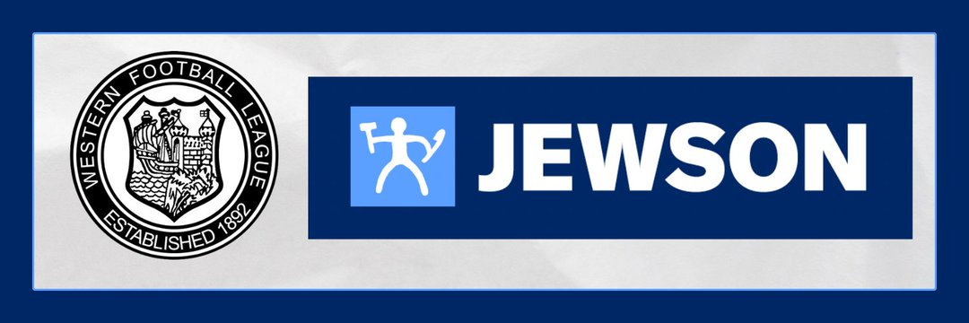

League Tables

 | PREMIER DIVISION | Played | Won | Drawn | Lost | GD | Points
1 | Portishead Town | 7 | 5 | 2 | 0 | 10 | 17
2 | Clevedon Town | 7 | 5 | 1 | 1 | 16 | 16
3 | Street | 6 | 5 | 1 | 0 | 8 | 16
4 | Buckland Athletic | 6 | 5 | 0 | 1 | 15 | 15
5 | Brislington | 7 | 5 | 0 | 2 | 14 | 15
6 | Barnstaple Town | 6 | 4 | 1 | 1 | 3 | 13
7 | Bridgwater United | 7 | 4 | 1 | 2 | 2 | 13
8 | Nailsea & Tickenham | 5 | 4 | 0 | 1 | 7 | 12
9 | Paulton Rovers | 6 | 4 | 0 | 2 | 1 | 12
10 | Oldland Abbotonians | 6 | 3 | 0 | 3 | 1 | 9
11 | St Blazey | 6 | 2 | 2 | 2 | -4 | 8
12 | Brixham AFC | 6 | 1 | 4 | 1 | 2 | 7
13 | Ilfracombe Town | 8 | 2 | 1 | 5 | -4 | 7
14 | Ivybridge Town | 8 | 2 | 1 | 5 | -4 | 7
15 | Wellington | 7 | 2 | 0 | 5 | -8 | 6
16 | Shepton Mallet | 6 | 1 | 2 | 3 | -1 | 5
17 | AFC St Austell | 6 | 1 | 0 | 5 | -7 | 3
18 | Torpoint Athletic | 8 | 1 | 0 | 7 | -15 | 3
19 | Saltash United | 7 | 0 | 2 | 5 | -11 | 2
20 | Welton Rovers | 7 | 0 | 0 | 7 | -25 | 0

 | FIRST DIVISION | Played | Won | Drawn | Lost | GD | Points
1 | Hallen | 8 | 6 | 2 | 0 | 14 | 20
2 | Calne Town | 7 | 6 | 1 | 0 | 14 | 19
3 | Bradford Town | 7 | 6 | 0 | 1 | 10 | 18
4 | Wells City | 9 | 5 | 2 | 2 | 11 | 17
5 | Avonmouth | 10 | 5 | 1 | 4 | 8 | 16
6 | Cadbury Heath | 8 | 5 | 1 | 2 | 2 | 16
7 | Devizes Town | 8 | 4 | 2 | 2 | 11 | 14
8 | Mendip Broadwalk | 9 | 4 | 2 | 3 | -5 | 14
9 | Shirehampton | 7 | 4 | 1 | 2 | 7 | 13
10 | Bitton | 8 | 4 | 1 | 3 | 2 | 13
11 | Longwell Green Sports | 8 | 4 | 1 | 3 | 1 | 13
12 | Cribbs Reserves | 10 | 4 | 1 | 5 | -1 | 13
13 | Bristol Telephones | 7 | 4 | 0 | 3 | 7 | 12
14 | Sturminster Newton United | 8 | 3 | 2 | 3 | 1 | 11
15 | Keynsham Town | 8 | 3 | 1 | 4 | -9 | 10
16 | Warminster Town | 8 | 2 | 3 | 3 | -5 | 9
17 | AEK Boco | 9 | 2 | 0 | 7 | -5 | 6
18 | Odd Down | 9 | 1 | 3 | 5 | -6 | 6
19 | Radstock Town | 8 | 2 | 0 | 6 | -8 | 6
20 | Hengrove Athletic | 8 | 1 | 2 | 5 | -9 | 5
21 | Cheddar | 8 | 1 | 1 | 6 | -15 | 4
22 | Gillingham Town | 8 | 0 | 1 | 7 | -25 | 1

